INTRODUCTION TO JAVA
WEEK 2 GIT VERSION CONTROL
DAY 1 GIT

Git Version Control

A version control system is a software that tracks changes to a file or set of files over time so that you can recall specific versions later. It also allows you to work together with other programmers or developers. The version control system is a collection of software tools that help a team to manage changes in a source code. It uses a special kind of database to keep track of every modification to the code.
There are several git hosting services (remote repository) in the market. Some are free and some are commercial. These include GitHub, Bitbucket and Gitlab.

What is Git?

Git is an open-source distributed version control system. It is designed to handle minor to major projects with high speed and efficiency. It is developed to co-ordinate the work among the developers. The version control allows us to track and work together with our team members at the same workspace.
Git is foundation of many services like GitHub and GitLab, but we can use Git without using any other Git services. Git can be used privately and publicly.
Git was created by Linus Torvalds in 2005 to develop Linux Kernel. Git is easy to learn, and has fast performance. It is superior to other SCM tools like Subversion, CVS, Perforce, and ClearCase.
Git is widely regarded as a popular and robust version control system, and its success can be attributed to various features that cater to the needs of developers and teams. Here are nine prominent features of Git:
1. Distributed Version Control:
- Description: Git is a distributed version control system, meaning that every developer has a full copy of the entire repository, including its history. This allows developers to work offline, make local commits, and collaborate more effectively.
2. Branching and Merging:
- Description: Git makes branching and merging simple and efficient. Developers can create branches to work on specific features or fixes independently, and later merge those branches back into the main codebase. This facilitates parallel development and helps in managing complex projects.
3. Speed and Performance:
- Description: Git is designed to be fast and performant. Operations such as committing, branching, and merging are generally quick, even with large repositories. Git's internal data structures and algorithms contribute to its speed.
4. Security and Integrity:
- Description: Git uses cryptographic hash functions to ensure the integrity of data. Each commit is identified by a unique hash, and any changes to the code or history will result in a new hash. This makes it difficult for unauthorized changes to go undetected.
5. Open Source and Community Support:
- Description: Git is open source, meaning its source code is freely available for anyone to inspect, modify, and contribute to. This has led to a vibrant and supportive community, resulting in a wealth of resources, plugins, and third-party tools that enhance Git's functionality.
6. Flexibility:
- Description: Git is versatile and can be used in various development workflows. Whether it's a centralized, decentralized, or hybrid model, Git can adapt to different collaboration styles. This flexibility makes it suitable for projects of different sizes and complexities.
7. Staging Area (Index):
- Description: Git introduces a staging area, also known as the index, which allows developers to selectively choose which changes to include in the next commit. This enables more fine-grained control over commits and helps in crafting clean, logical commit histories.
8. Excellent Branching Model:
- Description: Git's branching model is one of its strongest features. Branches are lightweight and easy to create, allowing developers to experiment with new features without affecting the main codebase. The ability to merge branches efficiently contributes to a streamlined development process.

9. Large Ecosystem and Integration:
- Description: Git integrates well with a vast ecosystem of tools and services. It is often used in conjunction with platforms like GitHub, GitLab, and Bitbucket for hosting repositories. Additionally, various IDEs and continuous integration tools have built-in support for Git, making it seamless to incorporate into different workflows.

These features collectively contribute to Git's popularity and make it a preferred choice for version control in a wide range of software development projects.

Benefits of using Git
A version control application allows us to keep track of all the changes that we make in the files of our project(s). Every time we make changes in files of an existing project, we can push those changes to a repository.
Other developers are allowed to pull your changes from the repository and continue to work with the updates that you added to the project files.
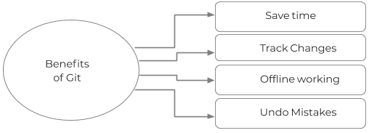
Benefits of git
Major benefits of Git are:
Saves Time
Git is lightning fast technology. Each command takes only a few seconds to execute so we can save a lot of time as compared to login to a GitHub account and find out its features.
Offline Working
One of the most important benefits of Git is that it supports offline working. If we are facing internet connectivity issues, it will not affect our work. In Git, we can do almost everything locally. Comparatively, other CVS like SVN is limited and prefer the connection with the central repository
Undo Mistakes
One additional benefit of Git is we can Undo mistakes. Sometimes the undo can be a savior option for us. Git provides the undo option for almost everything.
Track the Changes
Git facilitates with some exciting features such as Diff, Log, and Status, which allows us to track changes so we can check the status, compare our files or branches.

Instructions for configuration
Configuring Git
Now that we have install git lets config our environment. To configure we use the git config command
Git supports a command called git config that lets you get and set configuration variables that control all facets of how Git looks and operates. It is used to set Git configuration values on a global or local project level.
Setting user.name and user.email are the necessary configuration options as your name and email will show up in your commit messages.
Setting username
The username is used by the Git for each commit.
$ git config --global user.name "Firstname Lastname"
Setting email id
The Git uses this email id for each commit.
$ git config --global user.email "test@mydomain.com"
Other configuration options include:
Setting editor
You can set the default text editor when Git needs you to type in a message. If you have not selected any of the editors, Git will use your default system's editor.
To select a different text editor, such as Vim,
$ git config --global core.editor Vim
Checking Your Settings
You can check your configuration settings; you can use the git config --list command to list all the settings that Git can find at that point.
$ git config -list.
Colored output
You can customize your Git output to view a personalized color theme. The git config can be used to set these color themes.
Color.ui
$ Git config -global color.ui true
The default value of color.ui is set as auto, which will apply colors to the immediate terminal output stream. You can set the colour value as true, false, auto, and always.
Git configuration levels
The git config command can accept arguments to specify the configuration level. The following configuration levels are available in the Git config.
- local
- global
- system
--local
It is the default level in Git. Git config will write to a local level if no configuration option is given. Local configuration values are stored in .git/config directory as a file.
--global
The global level configuration is user-specific configuration. User-specific means, it is applied to an individual operating system user. Global configuration values are stored in a user's home directory.
--system
The system-level configuration is applied across an entire system. The entire system means all users on an operating system and all repositories. The system-level configuration file stores in a gitconfig file off the system directory.
The order of priority of the Git config is local, global, and system, respectively. It means when looking for a configuration value, Git will start at the local level and bubble up to the system level.

DAY 2 GIT TOOLS AND PACKAGES

Git Tools
To explore the robust functionality of Git, we should learn about git tools. Git comes with some tools like Git Bash, Git GUI to provide the interface between machine and user. It supports inbuilt as well as third-party tools.
Git comes with built-in GUI tools like git bash, git-gui, and gitk for committing and browsing. It also supports several third-party tools for users looking for platform-specific experience.

Git Package Tools
Git provides powerful functionality tools such as commands, command line, Git GUI. Let's have a glimpse of some essential package tools.

GitBash
Git Bash is an application for the Windows environment. It is used as Git command line for windows. Git Bash provides an emulation layer for a Git command-line experience. Bash is an abbreviation of Bourne Again Shell. Git package installer contains Bash, bash utilities, and Git on a Windows operating system.
Bash is a standard default shell on Linux and macOS. A shell is a terminal application which is used to create an interface with an operating system through commands.
By default, Git Windows package contains the Git Bash tool. We can access it by right-click on a folder in Windows Explorer.

Git Bash Commands
Git Bash comes with some additional commands that are stored in the /usr/bin directory of the Git Bash emulation. Git Bash can provide a robust shell experience on Windows. Git Bash comes with some essential shell commands like Ssh, scp, cat, find.
Git Bash also includes the full set of Git core commands like git clone, git commit, git checkout, git push, and more.

Git GUI
Git GUI is a powerful alternative to Git BASH. It offers a graphical version of the Git command line function, as well as comprehensive visual diff tools. We can access it by simply right click on a folder or location in windows explorer. Also, we can access it through the command line by typing below command.
$ git gui
A pop-up window will open as Git gui tool. The Git GUI's interface looks like as:
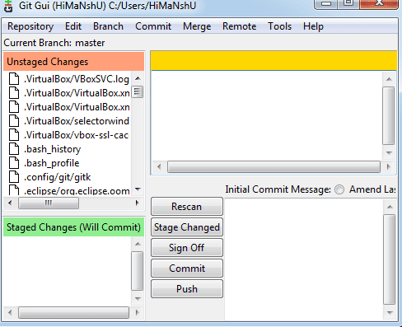
Git facilitates with some built-in GUI tools for committing (git-gui) and browsing (gitk), but there are many third-party tools for users looking for platform-specific experience.

Gitk
gitk is a graphical history viewer tool. It's a robust GUI shell over git log and git grep. This tool is used to find something that happened in the past or visualize your project's history.
Gitk can invoke from the command-line. Just change directory into a Git repository, and type:
$ gitk [git log options]
GIT TERMINOLOGY

Git has vast terminology and jargon, which can often be difficult for new users, or those who know Git basics but want to become Git masters. Let’s expound and explore the terminology behind the tools. Let's have a glimpse at the commonly used terms.
Branch
A branch is a version of the repository that diverges from the main working project. It is an essential feature available in most modern version control systems. A Git project can have more than one branch. We can perform many operations on Git branch-like rename, list, delete, etc.
Checkout
In Git, the term checkout is used for the act of switching between different versions of a target entity. The git checkout command is used to switch between branches in a repository.
Cherry-Picking
Cherry-picking in Git is meant to apply some commit from one branch into another branch. In case you made a mistake and committed a change into the wrong branch, but do not want to merge the whole branch. You can revert the commit and cherry-pick it on another branch.
Clone
The git clone is a Git command-line utility. It is used to make a copy of the target repository or clone it. If I want a local copy of my repository from GitHub, this tool allows creating a local copy of that repository on your local directory from the repository URL.
Fetch
It is used to fetch branches and tags from one or more other repositories, along with the objects necessary to complete their histories. It updates the remote-tracking branches.
HEAD
HEAD is the representation of the last commit in the current checkout branch. We can think of the head like a current branch. When you switch branches with git checkout, the HEAD revision changes, and points to the new branch.
Index
The Git index is a staging area between the working directory and repository. It is used as the index to build up a set of changes that you want to commit together.
Master
Master is a naming convention for Git branch. It's a default branch of Git. After cloning a project from a remote server, the resulting local repository contains only a single local branch. This branch is called a "master" branch. It means that "master" is a repository's "default" branch.

Merge
Merging is a process to put a forked history back together. The git merge command facilitates you to take the data created by git branch and integrate them into a single branch.
Origin
In Git, "origin" is a reference to the remote repository from a project was initially cloned. More precisely, it is used instead of that original repository URL to make referencing much easier.
Pull/Pull Request
The term Pull is used to receive data from GitHub. It fetches and merges changes on the remote server to your working directory. The git pull command is used to make a Git pull.
Pull requests are a process for a developer to notify team members that they have completed a feature. Once their feature branch is ready, the developer files a pull request via their remote server account. Pull request announces all the team members that they need to review the code and merge it into the master branch.
Push
The push term refers to upload local repository content to a remote repository. Pushing is an act of transfer commits from your local repository to a remote repository. Pushing is capable of overwriting changes; caution should be taken when pushing.
Rebase
In Git, the term rebase is referred to as the process of moving or combining a sequence of commits to a new base commit. Rebasing is very beneficial and visualized the process in the environment of a feature branching workflow.
From a content perception, rebasing is a technique of changing the base of your branch from one commit to another.
Remote
In Git, the term remote is concerned with the remote repository. It is a shared repository that all team members use to exchange their changes. A remote repository is stored on a code hosting service like an internal server, GitHub, Subversion and more.
In case of a local repository, a remote typically does not provide a file tree of the project's current state, as an alternative it only consists of the .git versioning data.
Repository
In Git, Repository is like a data structure used by VCS to store metadata for a set of files and directories. It contains the collection of the file as well as the history of changes made to those files. Repositories in Git is considered as your project folder. A repository has all the project-related data. Distinct projects have distinct repositories.
Stashing
Sometimes you want to switch the branches, but you are working on an incomplete part of your current project. You don't want to make a commit of half-done work. Git stashing allows you to do so. The git stash command enables you to switch branch without committing the current branch.
Tag
Tags make a point as a specific point in Git history. It is used to mark a commit stage as important. We can tag a commit for future reference. Primarily, it is used to mark a projects initial point like v1.1. There are two types of tags.

Light-weighted tag
Annotated tag
Upstream and Downstream
The term upstream and downstream is a reference of the repository. Generally, upstream is where you cloned the repository from (the origin) and downstream is any project that integrates your work with other works. However, these terms are not restricted to Git repositories.
Git Revert
In Git, the term revert is used to revert some commit. To revert a commit, git revert command is used. It is an undo type command. However, it is not a traditional undo alternative
Git Reset
In Git, the term reset stands for undoing changes. The git reset command is used to reset the changes. The git reset command has three core forms of invocation. These forms are as follows.

Soft
Mixed
Hard
Git Ignore
In Git, the term ignore used to specify intentionally untracked files that Git should ignore. It doesn't affect the Files that are already tracked by Git.
Git Diff
Git diff is a command-line utility. It's a multi-use Git command. When it is executed, it runs a diff function on Git data sources. These data sources can be files, branches, commits, and more. It is used to show changes between commits, commit, and working tree, etc.
Git Cheat Sheet
A Git cheat sheet is a summary of Git quick references. It contains basic Git commands with quick installation. A cheat sheet or crib sheet is a brief set of notes used for quick reference. Cheat sheets are so named because the people may use it without no prior knowledge.
Git Flow
GitFlow is a branching model for Git, developed by Vincent Driessen. It is very well organized to collaborate and scale the development team. Git flow is a collection of Git commands. It accomplishes many repository operations with just single commands.
Git Squash
In Git, the term squash is used to squash previous commits into one. Git squash is an excellent technique to group-specific changes before forwarding them to others. You can merge several commits into a single commit with the powerful interactive rebase command.
Git Rm
In Git, the term rm stands for remove. It is used to remove individual files or a collection of files. The key function of git rm is to remove tracked files from the Git index. Additionally, it can be used to remove files from both the working directory and staging index.
Git Fork
A fork is a rough copy of a repository. Forking a repository allows you to freely test and debug with changes without affecting the original project.

Great use of using forks to propose changes for bug fixes. To resolve an issue for a bug that you found, you can:
Fork the repository.
Make the fix.
Forward a pull request to the project owner.
Activity 1
Instructions:
1. What is the difference between git reset and git revert?
When would you use one over the other?
2. What is the difference between git merge and git rebase?
When would you use one over the other?
3. What is the difference between git stash pop and git stash apply?
When would you use one over the other?
4. What kinds of things can you do in interactive mode when rebasing?
Answers:
1. Difference between `git reset` and `git revert`:
- git reset`:
- Description: `git reset` is used to reset the current branch to a specified commit, either discarding changes or preserving them in the working directory.
- Use Cases: It is often used to undo local commits that haven't been pushed yet or to unstage changes. Be cautious when using it on commits that have been pushed to a shared repository, as it rewrites history.
- `git revert`:
- Description: `git revert` is used to create a new commit that undoes the changes made in a specific commit. It does not modify existing commits but instead adds a new commit that undoes the previous changes.
- Use Cases: Use `git revert` when you want to undo changes in a way that doesn't rewrite history, making it safer for shared branches. It's useful for rolling back changes in a collaborative environment without affecting others.
2. Difference between `git merge` and `git rebase`:
- `git merge`:
- Description:`git merge` integrates changes from one branch into another. It creates a new commit that has two parent commits, preserving the history of both branches.
- Use Cases: Use `git merge` when you want to combine the changes from one branch into another and maintain a clear history of the changes made on each branch.
- git rebase`:
- Description: `git rebase` moves or combines a sequence of commits to a new base commit. It essentially rewrites the commit history, resulting in a linear history without the branching structure seen in a merge.
- Use Cases: Use `git rebase` when you want a cleaner, linear history. It is useful for feature branches to incorporate changes from the main branch and resolve conflicts before merging. However, avoid rebasing commits that you've already pushed to a shared repository.
3. Difference between `git stash pop` and `git stash apply`:
- git stash pop`:
- Description: `git stash pop` is used to apply the most recently stashed changes and remove them from the stash. It's a combination of `git stash apply` and `git stash drop`.
- Use Cases: Use `git stash pop` when you want to apply and remove the latest stash in one command.
- git stash apply`:
- Description: `git stash apply` is used to apply changes from a stash to your working directory without removing it from the stash. The stash remains, and you can apply it again later if needed.
- Use Cases: Use `git stash apply` when you want to keep the stash for future use or if you have multiple stashes and want to selectively apply them.
4. Interactive Mode when Rebasing:
- When rebasing interactively (`git rebase -i`), you can:
- Rearrange Commits: Change the order of commits.
- Edit Commits: Modify commit messages, squash multiple commits into one, or split a commit into multiple commits.
- Delete Commits: Remove unnecessary or incorrect commits.
- Execute Commands: Run custom commands during the rebase process.
Interactive rebase provides flexibility in shaping the commit history according to your needs, but it should be used with caution, especially if the branch is shared with others.
DAY 3 GIT BASIC COMMANDS

Basic Git Command
Here is a list of git commands that commonly:
- Git Config
- Git init
- Git clone
- Git add
- Git commit
- Git status
- Git push
- Git pull
- Git Branch
- Git Merge
- Git log
- Git remote

Git clone command
This command is used to make a copy of a repository from an existing URL. If I want a local copy of my repository from GitHub, this command allows creating a local copy of that repository on your local directory from the repository URL.
Syntax
$ git clone URL

Git add command
This command is used to add one or more files to staging (Index) area.
Syntax
To add one file
$ git add Filename
To add more than one file
$ git add*

Git commit command
Commit command is used in two scenarios. They are as follows.
Git commit -m
This command changes the head. It records or snapshots the file permanently in the version history with a message.
Syntax
$ git commit -m " Commit Message"
Git commit -a
This command commits any files added in the repository with git add and also commits any files you've changed since then.
Syntax
$ git commit -a

Git status command
The status command is used to display the state of the working directory and the staging area. It allows you to see which changes have been staged, which haven't, and which files aren?t being tracked by Git. It does not show you any information about the committed project history. For this, you need to use the git log. It also lists the files that you've changed and those you still need to add or commit.
Syntax
$ git status

Git push Command
It is used to upload local repository content to a remote repository. Pushing is an act of transfer commits from your local repository to a remote repo. It's the complement to git fetch, but whereas fetching imports commits to local branches on comparatively pushing exports commits to remote branches. Remote branches are configured by using the git remote command. Pushing is capable of overwriting changes, and caution should be taken when pushing.
Git push command can be used as follows.
Git push origin master
This command sends the changes made on the master branch, to your remote repository.
Syntax
$ git push [variable name] master

Git push -all
This command pushes all the branches to the server repository.
Syntax
$ git push --all

Git pull command
Pull command is used to receive data from GitHub. It fetches and merges changes on the remote server to your working directory.
Syntax
$ git pull URL

Git Branch Command
This command lists all the branches available in the repository.
Syntax
$ git branch

Git Merge Command
This command is used to merge the specified branch?s history into the current branch.
Syntax
$ git merge BranchName

Git log Command
This command is used to check the commit history.
Syntax
$ git log
By default, if no argument passed, Git log shows the most recent commits first. We can limit the number of log entries displayed by passing a number as an option, such as -3 to show only the last three entries.
$ git log -3
How to create a GitHub account
Creating a GitHub account is a straightforward process. Follow these steps to create your own GitHub account:
1. Visit GitHub Website:
Open your web browser and go to the GitHub website: [GitHub](https://github.com/).
2. Sign Up:
On the GitHub homepage, click on the "Sign up" button. This is usually located in the upper-right corner.

3. Enter Your Information:
Fill out the required information in the "Create your account" form. This typically includes:
- Username: Choose a unique username that will be your GitHub identity.
- Email Address: Provide a valid email address.
- Password: Create a strong and secure password.

4. Complete the CAPTCHA:
- Complete any CAPTCHA or verification process that GitHub may require to ensure you are not a robot.
5. Choose a Plan:
- GitHub offers both free and paid plans. Choose the plan that best suits your needs. For most individuals and small teams, the free plan (GitHub Free) is sufficient.

6. Verify Your Email Address:
- After completing the registration, GitHub will send a verification email to the address you provided. Open the email and click on the verification link to confirm your email address.
7. Set Up Your Profile:
Once your email is verified, you can set up your GitHub profile. You can add a profile picture, bio, and other details to personalize your profile.
8. Explore GitHub:
After completing the signup process, you can start exploring GitHub. You can create repositories, collaborate with others, and contribute to open-source projects.
That's it! You now have a GitHub account. You can use your GitHub account to host your projects, collaborate with others, and contribute to the global community of developers. Remember to keep your login credentials secure and follow best practices for online account security.

STAGING AND COMMIT
We will discuss major Staging and Committing Operations in Git. We will focus on Git Add, Git Commit, Git Clone and Git Fork.

Git Add
The git add command is used to add file contents to the Index (Staging Area). This command updates the current content of the working tree to the staging area. It also prepares the staged content for the next commit. Every time we add or update any file in our project, it is required to forward updates to the staging area.
The git add command is a core part of Git technology. It typically adds one file at a time, but there some options are available that can add more than one file at once.
The "index" contains a snapshot of the working tree data. This snapshot will be forwarded for the next commit.
The git add command can be run many times before making a commit. These all add operations can be put under one commit. The add command adds the files that are specified on command line.
Git add command is a straight forward command. It adds files to the staging area. We can add single or multiple files at once in the staging area. It will be run as:
$ git add <File name>
The above command is added to the git staging area, but yet it cannot be shared on the version control system. A commit operation is needed to share it.
Git Add All
We can add more than one files in Git, but we have to run the add command repeatedly. Git facilitates us with a unique option of the add command by which we can add all the available files at once. To add all the files from the repository, run the add command with -A option. We can use '.' Instead of -A option. This command will stage all the files at a time. It will run as follows:
$ git add -A Or $ git add.
Add all New and Updated Files Only:
Git allows us to stage only updated and newly created files at once. We will use the ignore removal option to do so. It will be used as follows:
$ git add --ignore-removal
Add all Modified and Deleted Files
Git add facilitates us with a variety of options. There is another option that is available in Git, which allows us to stage only the modified and deleted files. It will not stage the newly created file. To stage all modified and deleted files only, run the below command:
$ git add -u
Add Files by Wildcard
Git allows us to add all the same pattern files at once. It is another way to add multiple files together. Suppose I want to add all java files or text files, then we can use pattern .java or .txt. To do so, we will run the command as follows, The below command will stage all the Java files
$ git add *.java

Git Commit
It is used to record the changes in the repository. It is the next command after the git add. Every commit contains the index data and the commit message. Every commit forms a parent-child relationship. When we add a file in Git, it will take place in the staging area. A commit command is used to fetch updates from the staging area to the repository.
The staging and committing are co-related to each other. Staging allows us to continue in making changes to the repository, and when we want to share these changes to the version control system, committing allows us to record these changes.
Commits are the snapshots of the project. Every commit is recorded in the master branch of the repository. We can recall the commits or revert it to the older version. Two different commits will never overwrite because each commit has its own commit-id. This commit-id is a cryptographic number created by SHA (Secure Hash Algorithm) algorithm
The commit command will commit the changes and generate a commit-id. The commit command without any argument will open the default text editor and ask for the commit message. We can specify our commit message in this text editor. It will run as follows:
$ git commit
The above command will prompt a default editor and ask for a commit message.
Git commit -a
The commit command also provides -a option to specify some commits. It is used to commit the snapshots of all changes. This option only considers already added files in Git. It will not commit the newly created files. Consider below scenario:
We have made some updates to our already staged file newfile3 and create a file newfile4.txt. Check the status of the repository and run the commit command as follows:
$ git commit -a
Git commit -m
The -m option of commit command lets you to write the commit message on the command line. This command will not prompt the text editor. It will run as follows:
$ git commit -m "Commit message."
Git Commit Amend (Change commit message)
The amend option lets us to edit the last commit. If accidentally, we have committed a wrong commit message, then this feature is a savage option for us. It will run as follows:
$ git commit -amend

Git Clone
In Git, cloning is the act of making a copy of any target repository. The target repository can be remote or local. You can clone your repository from the remote repository to create a local copy on your system. Also, you can sync between the two locations.
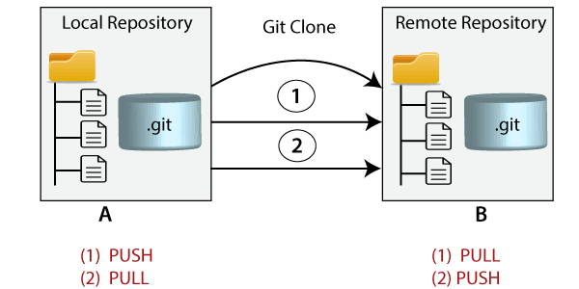
The git clone is a command-line utility which is used to make a local copy of a remote repository. It accesses the repository through a remote URL.
Usually, the original repository is located on a remote server, often from a Git service like GitHub, Bitbucket, or GitLab. The remote repository URL is referred to the origin.
$ git clone <repository URL>

Git Clone Branch
Git allows making a copy of only a particular branch from a repository. You can make a directory for the individual branch by using the git clone command. To make a clone branch, you need to specify the branch name with -b command. Below is the syntax of the command to clone the specific git branch:
$ git clone -b <Branch name><Repository URL>

Git Fork
A fork is a rough copy of a repository. Forking a repository allows you to freely test and debug with changes without affecting the original project. One of the excessive use of forking is to propose changes for bug fixing. To resolve an issue for a bug that you found, you can:
- Fork the repository.
- Make the fix.
- Forward a pull request to the project owner.
Forking is not a Git function; it is a feature of Git service like GitHub.
Generally, forking a repository allows us to experiment on the project without affecting the original project. Following are the reasons for forking the repository:

How to Fork a Repository on GitHub?
The forking and branching are excellent ways to contribute to an open-source project. These two features of Git allow the enhanced collaboration on the projects.
Forking is a safe way to contribute. It allows us to make a rough copy of the project. We can freely experiment on the project. After the final version of the project, we can create a pull request for merging.
It is a straight-forward process. Steps for forking the repository are as follows:
- Login to the GitHub account.
- Find the GitHub repository which you want to fork.
- Click the Fork button on the upper right side of the repository's page.
We can't fork our own repository. Only shared repositories can be fork. If someone wants to fork the repository, then he must log in with his account.

DAY 4 GIT LOG AND GIT CHECKOUT
INSPECT AND UNDO CHANGES

Git log
The advantage of a version control system is that it records changes. These records allow us to retrieve the data like commits, figuring out bugs, updates. But, all of this history will be useless if we cannot navigate it. At this point, we need the git log command.
Git log is a utility tool to review and read a history of everything that happens to a repository. Multiple options can be used with a git log to make history more specific.
Generally, the git log is a record of commits. A git log contains the following data:
- A commit hash, which is a 40-character checksum data generated by SHA (Secure Hash Algorithm) algorithm. It is a unique number.
- Commit Author metadata: The information of authors such as author name and email.
- Commit Date metadata: It's a date timestamp for the time of the commit.
- Commit title/message: It is the overview of the commit given in the commit message.

Basic Git log
Git log command is one of the most usual commands of git. It is the most useful command for Git. Every time you need to check the history, you have to use the git log command. The basic git log command will display the most recent commits and the status of the head. It will use as:
$ git log
The above command is listing all the recent commits. Each commit contains some unique sha-id, which is generated by the SHA algorithm. It also includes the date, time, author, and some additional details.

Git Log Stat
The log command displays the files that have been modified. It also shows the number of lines and a summary line of the total records that have been updated.
Generally, we can say that the stat option is used to display
- the modified files,
- The number of lines that have been added or removed
- A summary line of the total number of records changed
- The lines that have been added or removed.
It will be used as follows:
$ git log --stat
Git log P or Patch
The git log patch command displays the files that have been modified. It also shows the location of the added, removed, and updated lines.
It will be used as:
$ git log --patch Or $ git log -p
Generally, we can say that the --patch flag is used to display:
- Modified files
- The location of the lines that you added or removed
- Specific changes that have been made.

Git Checkout
In Git, the term checkout is used for the act of switching between different versions of a target entity. The git checkout command is used to switch between branches in a repository. Be careful with your staged files and commits when switching between branches.
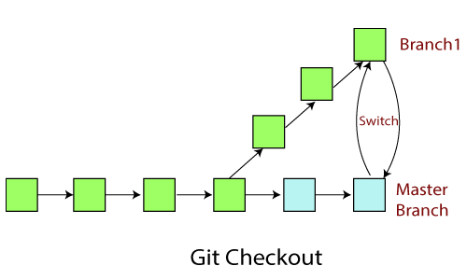
The git checkout command operates upon three different entities which are files, commits, and branches. Sometimes this command can be dangerous because there is no undo option available on this command.
It checks the branches and updates the files in the working directory to match the version already available in that branch, and it forwards the updates to Git to save all new commit in that branch.

Operations on Git Checkout
We can perform many operations by git checkout command like the switch to a specific branch, create a new branch, checkout a remote branch, and more. The git branch and git checkout commands can be integrated.

Checkout Branch
To switch between branches, use the below command.
$ git checkout <branchname>
Create and Switch Branch
The git checkout commands let you create and switch to a new branch. You can not only create a new branch but also switch it simultaneously by a single command. The git checkout -b option is a convenience flag that performs run git branch <new-branch>operation before running git checkout <new-branch>.
$ git checkout -b <branchname>
Checkout Remote Branch
Git allows you to check out a remote branch by git checkout command. It is a way for a programmer to access the work of a colleague or collaborator for review and collaboration. Each remote repository contains its own set of branches. So, to check out a remote branch, you have first to fetch the contents of the branch.
$ git checkout <remotebranch>
Find out about the Inspect and Undo changes git operations
Git Diff
Git Status
Git Revert
Git Reset
Git Rm

SOLUTION:
Certainly! Let's explore the "Inspect and Undo changes" operations in Git:
1. Git Diff:
Description: `git diff` is used to show the changes between two commits, between a commit and the working directory, or between two branches.
Examples:
```bash
# Show the changes between the working directory and the last commit
git diff
# Show the changes between two commits
git diff commit-hash1 commit-hash2
# Show the changes in a specific file
git diff filename
2. Git Status
Description: `git status` provides information about the current state of the working directory. It shows which files are modified, which files are staged, and which files are untracked.

Example:
`bash
# Check the status of the working directory
git status
3. Git Revert:
Description: `git revert` is used to create a new commit that undoes the changes made in a specific commit. It does not modify existing commits but adds a new commit that undoes the previous changes.
Example:
bash
Revert the changes made in a specific commit
git revert commit-hash
4. Git Reset:
Description: `git reset` is used to reset the current branch to a specified commit, either discarding changes or preserving them in the working directory.
Examples:
bash
Discard changes in the working directory and staging area
git reset --hard
Reset to a specific commit, preserving changes in the working directory
git reset commit-hash
5. Git Rm:
Description: `git rm` is used to remove files from the working directory and staging area.
Examples:
bash
Remove a file from the working directory and staging area
git rm filename
Remove a file from the staging area but keep it in the working directory
git rm --cached filename
These Git commands are essential for inspecting changes, understanding the status of your repository, and undoing changes when needed. Use them in different scenarios based on your development workflow and requirements.

COLLABORATING
Collaborating in git git refers to sharing on code among several developers. We will look at code sharing is handled in Git.We will discuss major collaboration operations in Git. Our main focus will be on Git fetch, Git pull and Git Push.

Git Fetch
Git "fetch" Downloads commits, objects and refs from another repository. It fetches branches and tags from one or more repositories. It holds repositories along with the objects that are necessary to complete their histories to keep updated remote-tracking branches.
The "git fetch" command is used to pull the updates from remote-tracking branches. Additionally, we can get the updates that have been pushed to our remote branches to our local machines. As we know, a branch is a variation of our repositories main code, so the remote-tracking branches are branches that have been set up to pull and push from remote repository.
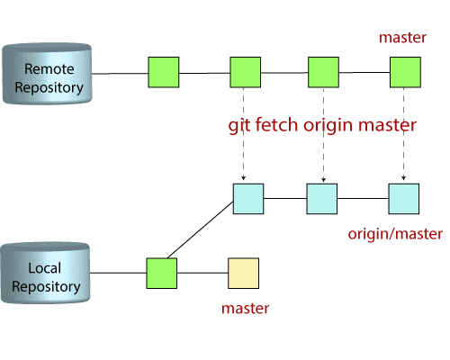
We can fetch the complete repository with the help of fetch command from a repository URL like a pull command does. See the below output:
$ git fetch< repository Url>
The git command that allows to fetch a specific branch from a repository. It will only access the element from a specific branch.
$ git fetch <branch URL><branch name>
The git fetch command allows to fetch all branches simultaneously from a remote repository.
$ git fetch -all

Git Pull / Pull Request
The term pull is used to receive data from GitHub. It fetches and merges changes from the remote server to your working directory. The git pull command is used to pull a repository.
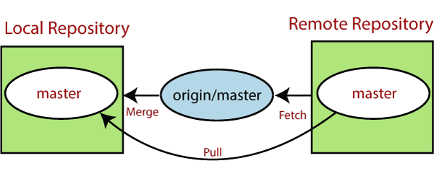
Pull request is a process for a developer to notify team members that they have completed a feature. Once their feature branch is ready, the developer files a pull request via their remote server account. Pull request announces all the team members that they need to review the code and merge it into the master branch.
The below figure demonstrates how pull acts between different locations and how it is similar or dissimilar to other related commands.
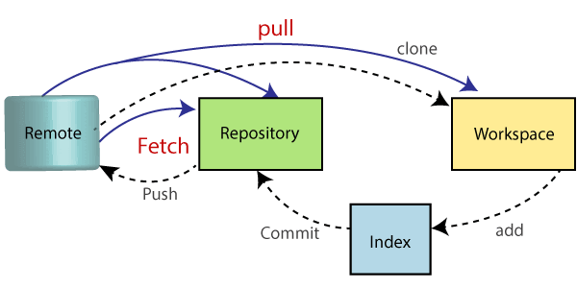

The "git pull" command
The pull command is used to access the changes (commits)from a remote repository to the local repository. It updates the local branches with the remote-tracking branches. Remote tracking branches are branches that have been set up to push and pull from the remote repository. Generally, it is a collection of the fetch and merges command. First, it fetches the changes from remote and combined them with the local repository.
The git pull command is syntax is:
$ git pull <option> [<repository URL><refspec>...]
In which:
<option>: Options are the commands; these commands are used as an additional option in a particular command. Options can be -q (quiet), -v (verbose), -e(edit) and more.
<repository URL>: Repository URL is your remote repository's URL where you have stored your original repositories like GitHub or any other git service.

Git Pull Remote Branch
Git allows fetching a particular branch. Fetching a remote branch is a similar process, as mentioned above, in git pull command.
$ git pull <remote branch URL>

Git Pull Origin Master
There is another way to pull the repository. We can pull the repository by using the git pull command. The syntax is given below:
$ git pull origin master

Git Push
The push term refers to upload local repository content to a remote repository. Pushing is an act of transfer commits from your local repository to a remote repository. Pushing is capable of overwriting changes; caution should be taken when pushing.
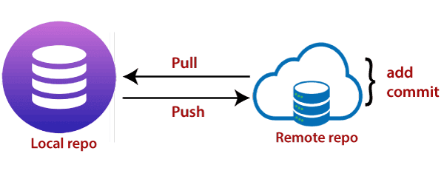
Moreover, we can say the push updates the remote refs with local refs. Every time you push into the repository, it is updated with some interesting changes that you made. If we do not specify the location of a repository, then it will push to default location at origin master.
The "git push" command is used to push into the repository. The push command can be considered as a tool to transfer commits between local and remote repositories. The basic syntax is given below:
$ git push <option> [<Remote URL><branch name><refspec>...]
Push command supports many additional options. Some options are as follows under push tags.
Git Push Tags
<repository>: The repository is the destination of a push operation. It can be either a URL or the name of a remote repository.
<refspec>: It specifies the destination ref to update source object.
--all: The word "all" stands for all branches. It pushes all branches.
--prune: It removes the remote branches that do not have a local counterpart. Means, if you have a remote branch say demo, if this branch does not exist locally, then it will be removed.
--mirror: It is used to mirror the repository to the remote. Updated or Newly created local refs will be pushed to the remote end. It can be force updated on the remote end. The deleted refs will be removed from the remote end.
--dry-run: Dry run tests the commands. It does all this except originally update the repository.
--tags: It pushes all local tags.
--delete: It deletes the specified branch.
-u: It creates an upstream tracking connection. It is very useful if you are going to push the branch for the first time.
Git Push Origin Master
Git push origin master is a special command-line utility that specifies the remote branch and directory. When you have multiple branches and directory, then this command assists you in determining your main branch and repository.
Generally, the term origin stands for the remote repository, and master is considered as the main branch. So, the entire statement "git push origin master" pushed the local content on the master branch of the remote location.
$ git push origin master

Git Force Push
The git force push allows you to push local repository to remote without dealing with conflicts. It is used as follows:
$ git push <remote><branch> -f OR $ git push <remote><branch> -force
How to Safe Force Push Repository:
There are several consequences of force pushing a repository like it may replace the work you want to keep. Force pushing with a lease option is capable of making fail to push if there are new commits on the remote that you didn't expect. If we say in terms of git, then we can say it will make it fail if remote contains untracked commit. It can be executed as:
$git push <remote><branch> --force-with-lease
Delete a Remote Branch
We can delete a remote branch using git push. It allows removing a remote branch from the command line. To delete a remote branch, perform below command:
$ git push origin -delete edited

